5 commands to check memory usage on Linux

[Linux](http://www.binarytides.com/category/linux/) By Silver Moon On Oct 26, 2013 [17 Comments](http://www.binarytides.com/linux-command-check-memory-usage/#comments)

Memory Usage

On linux, there are commands for almost everything, because the gui might not be always available. When working on servers only shell access is available and everything has to be done from these commands. So today we shall be checking the commands that can be used to check memory usage on a linux system. Memory include RAM and swap.

It is often important to check memory usage and memory used per process on servers so that resources do not fall short and users are able to access the server. For example a website. If you are running a webserver, then the server must have enough memory to serve the visitors to the site. If not, the site would become very slow or even go down when there is a traffic spike, simply because memory would fall short. Its just like what happens on your desktop PC.

1. free command

The free command is the most simple and easy to use command to check memory usage on linux. Here is a quick example

$ free -m

total used free shared buffers cached

Mem: 7976 6459 1517 0 865 2248

-/+ buffers/cache: 3344 4631

Swap: 1951 0 1951

The m option displays all data in MBs. The total os 7976 MB is the total amount of RAM installed on the system, that is 8GB. The used column shows the amount of RAM that has been used by linux, in this case around 6.4 GB. The output is pretty self explanatory. The catch over here is the cached and buffers column. The second line tells that 4.6 GB is free. This is the free memory in first line added with the buffers and cached amount of memory.

Linux has the habit of caching lots of things for faster performance, so that memory can be freed and used if needed.  
The last line is the swap memory, which in this case is lying entirely free.

2. /proc/meminfo

The next way to check memory usage is to read the /proc/meminfo file. Know that the /proc file system does not contain real files. They are rather virtual files that contain dynamic information about the kernel and the system.

$ cat /proc/meminfo

MemTotal: 8167848 kB

MemFree: 1409696 kB

Buffers: 961452 kB

Cached: 2347236 kB

SwapCached: 0 kB

Active: 3124752 kB

Inactive: 2781308 kB

Active(anon): 2603376 kB

Inactive(anon): 309056 kB

Active(file): 521376 kB

Inactive(file): 2472252 kB

Unevictable: 5864 kB

Mlocked: 5880 kB

SwapTotal: 1998844 kB

SwapFree: 1998844 kB

Dirty: 7180 kB

Writeback: 0 kB

AnonPages: 2603272 kB

Mapped: 788380 kB

Shmem: 311596 kB

Slab: 200468 kB

SReclaimable: 151760 kB

SUnreclaim: 48708 kB

KernelStack: 6488 kB

PageTables: 78592 kB

NFS_Unstable: 0 kB

Bounce: 0 kB

WritebackTmp: 0 kB

CommitLimit: 6082768 kB

Committed_AS: 9397536 kB

VmallocTotal: 34359738367 kB

VmallocUsed: 420204 kB

VmallocChunk: 34359311104 kB

HardwareCorrupted: 0 kB

AnonHugePages: 0 kB

HugePages_Total: 0

HugePages_Free: 0

HugePages_Rsvd: 0

HugePages_Surp: 0

Hugepagesize: 2048 kB

DirectMap4k: 62464 kB

DirectMap2M: 8316928 kB

Check the values of MemTotal, MemFree, Buffers, Cached, SwapTotal, SwapFree.  
They indicate same values of memory usage as the free command.

3. vmstat

The vmstat command with the s option, lays out the memory usage statistics much like the proc command. Here is an example

$ vmstat -s

8167848 K total memory

7449376 K used memory

3423872 K active memory

3140312 K inactive memory

718472 K free memory

1154464 K buffer memory

2422876 K swap cache

1998844 K total swap

0 K used swap

1998844 K free swap

392650 non-nice user cpu ticks

8073 nice user cpu ticks

83959 system cpu ticks

10448341 idle cpu ticks

91904 IO-wait cpu ticks

0 IRQ cpu ticks

2189 softirq cpu ticks

0 stolen cpu ticks

2042603 pages paged in

2614057 pages paged out

0 pages swapped in

0 pages swapped out

42301605 interrupts

94581566 CPU context switches

1382755972 boot time

8567 forks

$

The top few lines indicate total memory, free memory etc and so on.

4. top command

The top command is generally used to check memory and cpu usage per process. However it also reports total memory usage and can be used to monitor the total RAM usage. The header on output has the required information. Here is a sample output

top - 15:20:30 up 6:57, 5 users, load average: 0.64, 0.44, 0.33

Tasks: 265 total, 1 running, 263 sleeping, 0 stopped, 1 zombie

%Cpu(s): 7.8 us, 2.4 sy, 0.0 ni, 88.9 id, 0.9 wa, 0.0 hi, 0.0 si, 0.0 st

KiB Mem: 8167848 total, 6642360 used, 1525488 free, 1026876 buffers

KiB Swap: 1998844 total, 0 used, 1998844 free, 2138148 cached

PID USER PR NI VIRT RES SHR S %CPU %MEM TIME+ COMMAND

2986 enlighte 20 0 584m 42m 26m S 14.3 0.5 0:44.27 yakuake

1305 root 20 0 448m 68m 39m S 5.0 0.9 3:33.98 Xorg

7701 enlighte 20 0 424m 17m 10m S 4.0 0.2 0:00.12 kio_thumbnail

Check the KiB Mem and KiB Swap lines on the header. They indicate total, used and free amounts of the memory. The buffer and cache information is present here too, like the free command.

5. htop

Similar to the top command, the htop command also shows memory usage along with various other details.

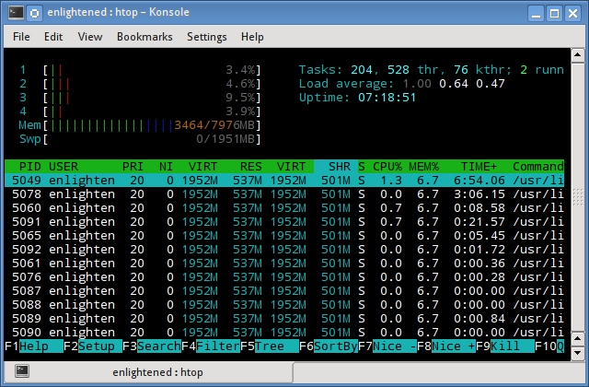

The header on top shows cpu usage along with RAM and swap usage with the corresponding figures.

RAM Information

To find out hardware information about the installed RAM, use the demidecode command. It reports lots of information about the installed RAM memory.

$ sudo dmidecode -t 17

# dmidecode 2.11

SMBIOS 2.4 present.

Handle 0x0015, DMI type 17, 27 bytes

Memory Device

Array Handle: 0x0014

Error Information Handle: Not Provided

Total Width: 64 bits

Data Width: 64 bits

Size: 2048 MB

Form Factor: DIMM

Set: None

Locator: J1MY

Bank Locator: CHAN A DIMM 0

Type: DDR2

Type Detail: Synchronous

Speed: 667 MHz

Manufacturer: 0xFF00000000000000

Serial Number: 0xFFFFFFFF

Asset Tag: Unknown

Part Number: 0x524D32474235383443412D36344643FFFFFF

Provided information includes the size (2048MB), type (DDR2) , speed(667 Mhz) etc.

Summary

All the above mentioned commands work from the terminal and do not have a gui. When working on a desktop with a gui, it is much easier to use a GUI tool with graphical output. The most common tools are gnome-system-monitor on gnome and  
ksysguard on KDE. Both provide resource usage information about cpu, ram, swap and network bandwidth in a graphical and easy to understand visual output.